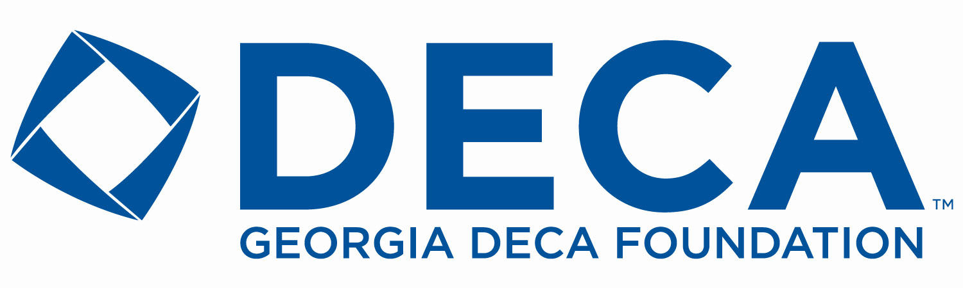
2019 ASPIRE STIPEND APPLICATION

NOTE: Georgia DECA Chapters may SUBMIT a maximum of 2 applications BY MARCH 15, 2019 and MUST BE A FOUNDATION MEMBER($25 Minimum) for consideration of any application.
The ASPIRE STIPEND is based on true financial need and is available to ICDC competition qualifiers who desire to compete at the International Career & Development Conference(ICDC).
Name:_______________________________ E-Mail:___________________________
Address:______________________________City:_________________ZIP Code:______
DECA Chapter:_________________________ DECA Advisor_______________________
Advisor Phone:_____________________ Advisor E-Mail__________________________
Please list CDC event won, position, and planned ICDC Event participation:
______________________________________________________________________________
Cumulative GPA: _____ Grade Level:____ Future Career Plans___________________________ ______________________________________________________________________________
Attach additional pages as follows:
- A description of your Georgia DECA experience…achievements, activities, and awards.
- Your future plans, how ICDC attendance will impact them, and why you are applying for our “needs-based” stipend. –MAXIMUM 500 WORDS
- Attach a signed recommendation letter from your Georgia DECA advisor verifying need.
It is understood that as an applicant for the Georgia DECA Foundation Aspire Stipend, there is a legitimate need which would prevent ICDC participation and that any stipend awarded, will be used to defray ICDC expenses.
MAIL TO: Georgia DECA Foundation, 1150 Great Oaks Drive, Lawrenceville, GA 30045

APPLICANT SIGNATURE_____________________ DATE__________________
PARENT SIGNATURE_____________________ ADVISOR SIGNATURE _____________________

